[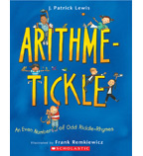](https://shop.scholastic.com/shop/en/teacherstore/product/Arithme-Tickle)[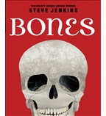](https://shop.scholastic.com/shop/en/teacherstore/product/Bones-9780545046527)[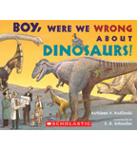](https://shop.scholastic.com/shop/en/teacherstore/product/Boy-Were-We-Wrong-About-Dinosaurs)[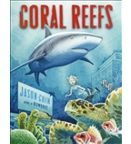](https://shop.scholastic.com/shop/en/teacherstore/product/Coral-Reefs-9780545449427)

[](https://shop.scholastic.com/shop/en/teacherstore/product/Extreme-Science-Careers)[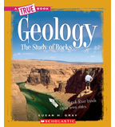](https://shop.scholastic.com/shop/en/teacherstore/product/Geology-The-Study-of-Rocks)[](https://shop.scholastic.com/shop/en/teacherstore/product/Making-Money-for-Kids)[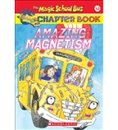](https://shop.scholastic.com/shop/en/teacherstore/product/Amazing-Magnetism)

[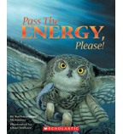](https://shop.scholastic.com/shop/en/teacherstore/product/Pass-the-Energy-Please)[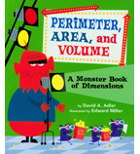](https://shop.scholastic.com/shop/en/teacherstore/product/Perimeter-Area-and-Volume)[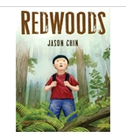](https://shop.scholastic.com/shop/en/teacherstore/product/Redwoods)[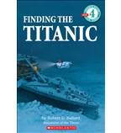](https://shop.scholastic.com/shop/en/teacherstore/product/Finding-the-Titanic)