[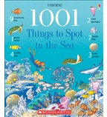](https://shop.scholastic.com/shop/en/teacherstore/product/1001-Things-to-Spot-in-the-Sea)[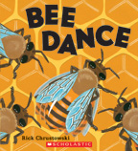](https://shop.scholastic.com/shop/en/teacherstore/product/Bee-Dance) [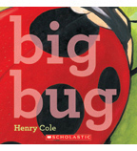](https://shop.scholastic.com/shop/en/teacherstore/product/Big-Bug) [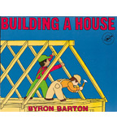](https://shop.scholastic.com/shop/en/teacherstore/product/Building-a-House)

[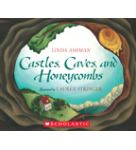](https://shop.scholastic.com/shop/en/teacherstore/product/Castles-Caves-and-Honeycombs)[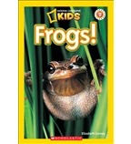](https://shop.scholastic.com/shop/en/teacherstore/product/Frogs-9780545251792)[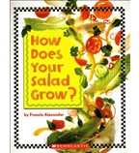](https://shop.scholastic.com/shop/en/teacherstore/product/How-Does-Your-Salad-Grow)[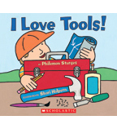](https://shop.scholastic.com/shop/en/teacherstore/product/I-Love-Tools)

[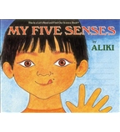](https://shop.scholastic.com/shop/en/teacherstore/product/My-Five-Senses)[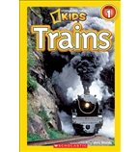](https://shop.scholastic.com/shop/en/teacherstore/product/National-Geographic-Kids-Readers-Trains)[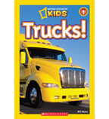](https://shop.scholastic.com/shop/en/teacherstore/product/Trucks-9780545498982)[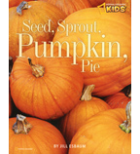](https://shop.scholastic.com/shop/en/teacherstore/product/Seed-Sprout-Pumpkin-Pie)