[](https://shop.scholastic.com/shop/en/teacherstore/product/Civil-War-Spies)[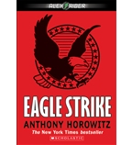](https://shop.scholastic.com/shop/en/teacherstore/product/Eagle-Strike)[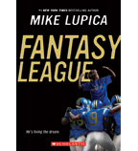](https://shop.scholastic.com/shop/en/teacherstore/product/Fantasy-League)[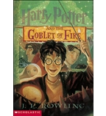](https://shop.scholastic.com/shop/en/teacherstore/product/Harry-Potter-and-the-Goblet-of-Fire)

[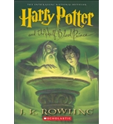](https://shop.scholastic.com/shop/en/teacherstore/product/Harry-Potter-and-the-Half-Blood-Prince)[](https://shop.scholastic.com/shop/en/teacherstore/product/The-Middle-East)[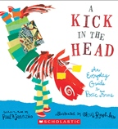](https://shop.scholastic.com/shop/en/teacherstore/product/A-Kick-in-the-Head)[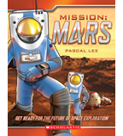](https://shop.scholastic.com/shop/en/teacherstore/product/Mission-Mars)

[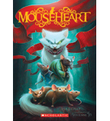](https://shop.scholastic.com/shop/en/teacherstore/product/Mouseheart)[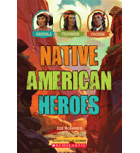](https://shop.scholastic.com/shop/en/teacherstore/product/Native-American-Heroes)[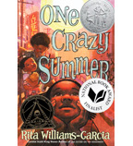](https://shop.scholastic.com/shop/en/teacherstore/product/One-Crazy-Summer)[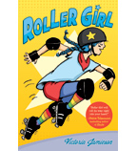](https://shop.scholastic.com/shop/en/teacherstore/product/Roller-Girl)

[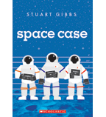](https://shop.scholastic.com/shop/en/teacherstore/product/Space-Case-9780545908580)[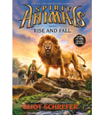](https://shop.scholastic.com/shop/en/teacherstore/product/Spirit-Animals-Rise-and-Fall)[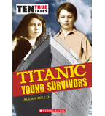](https://shop.scholastic.com/shop/en/teacherstore/product/Titanic)