[](https://shop.scholastic.com/shop/en/teacherstore/product/7-The-Stranger)[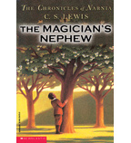](https://shop.scholastic.com/shop/en/teacherstore/product/The-Magicians-Nephew)[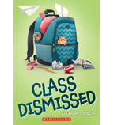](https://shop.scholastic.com/shop/en/teacherstore/product/Class-Dismissed-9780545915984)[](https://shop.scholastic.com/shop/en/teacherstore/product/A-Light-in-the-Storm)

[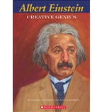](https://shop.scholastic.com/shop/en/teacherstore/product/Albert-Einstein)[](https://shop.scholastic.com/shop/en/teacherstore/product/George-Washingtons-Socks)[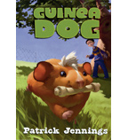](https://shop.scholastic.com/shop/en/teacherstore/product/Guinea-Dog)[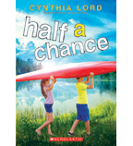](https://shop.scholastic.com/shop/en/teacherstore/product/Half-a-Chance-9780545837675)

[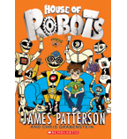](https://shop.scholastic.com/shop/en/teacherstore/product/House-of-Robots-House-of-Robots)[](https://shop.scholastic.com/shop/en/teacherstore/product/I-Survived-the-Nazi-Invasion-1944-9780545459389)[](https://shop.scholastic.com/shop/en/teacherstore/product/Kizzy-Ann-Stamps)[](https://shop.scholastic.com/shop/en/teacherstore/product/Love-that-Dog)

[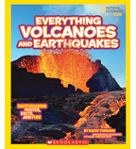](https://shop.scholastic.com/shop/en/teacherstore/product/Everything-Volcanoes-and-Earthquakes)[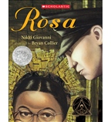](https://shop.scholastic.com/shop/en/teacherstore/product/Rosa)[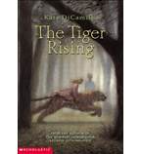](https://shop.scholastic.com/shop/en/teacherstore/product/The-Tiger-Rising)