[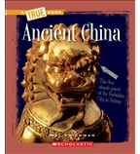](https://shop.scholastic.com/shop/en/teacherstore/product/Ancient-China)[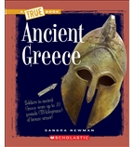](https://shop.scholastic.com/shop/en/teacherstore/product/Ancient-Greece)[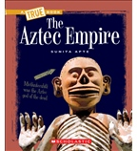](https://shop.scholastic.com/shop/en/teacherstore/product/The-Aztec-Empire)[](https://shop.scholastic.com/shop/en/teacherstore/product/Bad-Kitty-for-President)

[](https://shop.scholastic.com/shop/en/teacherstore/product/The-Cricket-in-Times-Square)[](https://shop.scholastic.com/shop/en/teacherstore/product/Guinea-Dog-2-9780545681292)[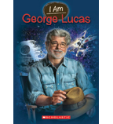](https://shop.scholastic.com/shop/en/teacherstore/product/George-Lucas)[](https://shop.scholastic.com/shop/en/teacherstore/product/I-Survived-the-Destruction-of-Pompeii-79-AD)

[](https://shop.scholastic.com/shop/en/teacherstore/product/More-Sideways-Arithmetic-from-Wayside-School)[](https://shop.scholastic.com/shop/en/teacherstore/product/The-Mouse-with-the-Question-Mark-Tail)[](https://shop.scholastic.com/shop/en/teacherstore/product/The-One-and-Only-Ivan-9780545842006)[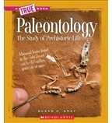](https://shop.scholastic.com/shop/en/teacherstore/product/Paleontology-The-Study-of-Prehistoric-Life)

[](https://shop.scholastic.com/shop/en/teacherstore/product/Secret-of-the-Mountain-Dog-9780545741118)[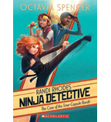](https://shop.scholastic.com/shop/en/teacherstore/product/The-Case-of-the-Time-Capsule-Bandit)[](https://shop.scholastic.com/shop/en/teacherstore/product/So-You-Want-to-Be-President)