[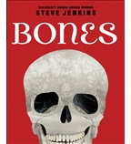](https://shop.scholastic.com/shop/en/teacherstore/product/Bones-9780545046527)[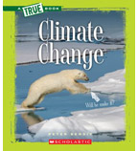](https://shop.scholastic.com/shop/en/teacherstore/product/Climate-Change) [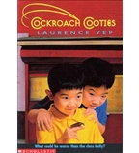](https://shop.scholastic.com/shop/en/teacherstore/product/Cockroach-Cooties)[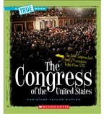](https://shop.scholastic.com/shop/en/teacherstore/product/The-Congress-of-the-United-States)

[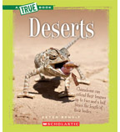](https://shop.scholastic.com/shop/en/teacherstore/product/Deserts-9780531281048)[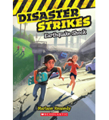](https://shop.scholastic.com/shop/en/teacherstore/product/Earthquake-Shock)[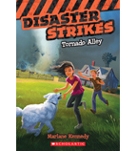](https://shop.scholastic.com/shop/en/teacherstore/product/Tornado-Alley-9780545530460)[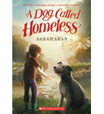](https://shop.scholastic.com/shop/en/teacherstore/product/A-Dog-Called-Homeless)

[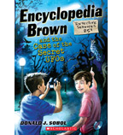](https://shop.scholastic.com/shop/en/teacherstore/product/Encyclopedia-Brown-and-the-Case-of-the-Secret-UFO)[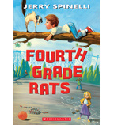](https://shop.scholastic.com/shop/en/teacherstore/product/Fourth-Grade-Rats)[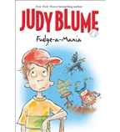](https://shop.scholastic.com/shop/en/teacherstore/product/Fudge-a-Mania)[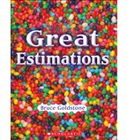](https://shop.scholastic.com/shop/en/teacherstore/product/Great-Estimations)

[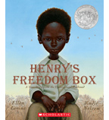](https://shop.scholastic.com/shop/en/teacherstore/product/Henrys-Freedom-Box)[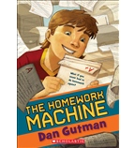](https://shop.scholastic.com/shop/en/teacherstore/product/The-Homework-Machine)[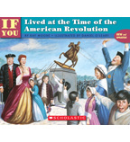](https://shop.scholastic.com/shop/en/teacherstore/product/If-You-Lived-at-the-Time-of-the-American-Revolution)