[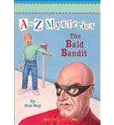](https://shop.scholastic.com/shop/en/teacherstore/product/The-Bald-Bandit)[](https://shop.scholastic.com/shop/en/teacherstore/product/You-Cant-Eat-Your-Chicken-Pox-Amber-Brown)[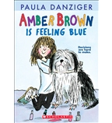](https://shop.scholastic.com/shop/en/teacherstore/product/Amber-Brown-Is-Feeling-Blue)[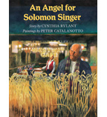](https://shop.scholastic.com/shop/en/teacherstore/product/An-Angel-for-Solomon-Singer)[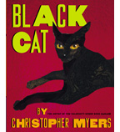](https://shop.scholastic.com/shop/en/teacherstore/product/Black-Cat)[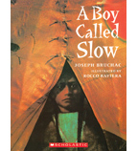](https://shop.scholastic.com/shop/en/teacherstore/product/A-Boy-Called-Slow)[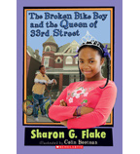](https://shop.scholastic.com/shop/en/teacherstore/product/The-Broken-Bike-Boy-and-the-Queen-of-33rd-Street)[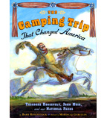](https://shop.scholastic.com/shop/en/teacherstore/product/The-Camping-Trip-That-Changed-America)[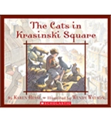](https://shop.scholastic.com/shop/en/teacherstore/product/The-Cats-in-Krasinski-Square) [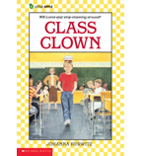](https://shop.scholastic.com/shop/en/teacherstore/product/Class-Clown)[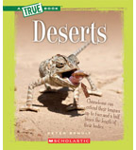](https://shop.scholastic.com/shop/en/teacherstore/product/Deserts-9780531281048) [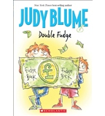](https://shop.scholastic.com/shop/en/teacherstore/product/Double-Fudge)[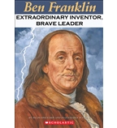](https://shop.scholastic.com/shop/en/teacherstore/product/Ben-Franklin-9780439020190)[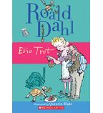](https://shop.scholastic.com/shop/en/teacherstore/product/Esio-Trot)[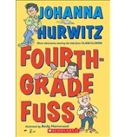](https://shop.scholastic.com/shop/en/teacherstore/product/Fourth-Grade-Fuss)[](https://shop.scholastic.com/shop/en/teacherstore/product/Frederick-Douglass-Fights-for-Freedom)[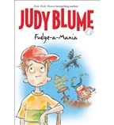](https://shop.scholastic.com/shop/en/teacherstore/product/Fudge-a-Mania)[](https://shop.scholastic.com/shop/en/teacherstore/product/Helen-Keller)[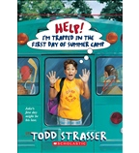](https://shop.scholastic.com/shop/en/teacherstore/product/Help-Im-Trapped-in-the-First-Day-of-Summer-Camp)[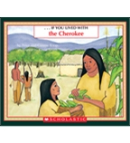](https://shop.scholastic.com/shop/en/teacherstore/product/If-You-Lived-With-the-Cherokee) [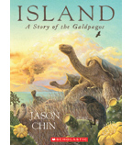](https://shop.scholastic.com/shop/en/teacherstore/product/Island)[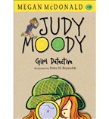](https://shop.scholastic.com/shop/en/teacherstore/product/Judy-Moody-Girl-Detective)[](https://shop.scholastic.com/shop/en/teacherstore/product/Just-a-Dog-9780545374538)[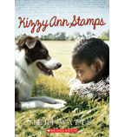](https://shop.scholastic.com/shop/en/teacherstore/product/Kizzy-Ann-Stamps)[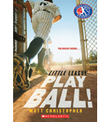](https://shop.scholastic.com/shop/en/teacherstore/product/Play-Ball-9780545679466)[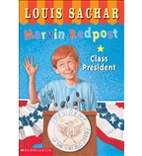](https://shop.scholastic.com/shop/en/teacherstore/product/Class-President-9780439106306)[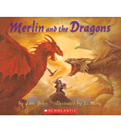](https://shop.scholastic.com/shop/en/teacherstore/product/Merlin-and-the-Dragons) [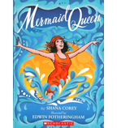](https://shop.scholastic.com/shop/en/teacherstore/product/Mermaid-Queen)[](https://shop.scholastic.com/shop/en/teacherstore/product/The-Midwest) [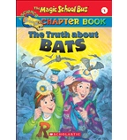](https://shop.scholastic.com/shop/en/teacherstore/product/The-Truth-About-Bats)[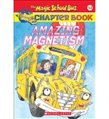](https://shop.scholastic.com/shop/en/teacherstore/product/Amazing-Magnetism)[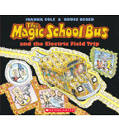](https://shop.scholastic.com/shop/en/teacherstore/product/The-Magic-School-Busreg-and-the-Electric-Field-Trip) [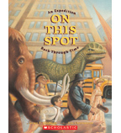](https://shop.scholastic.com/shop/en/teacherstore/product/On-This-Spot)[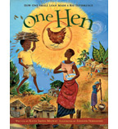](https://shop.scholastic.com/shop/en/teacherstore/product/One-Hen)[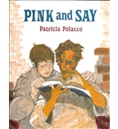](https://shop.scholastic.com/shop/en/teacherstore/product/Pink-and-Say)[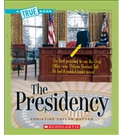](https://shop.scholastic.com/shop/en/teacherstore/product/The-Presidency) [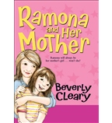](https://shop.scholastic.com/shop/en/teacherstore/product/Ramona-and-Her-Mother)[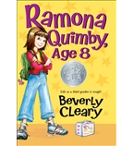](https://shop.scholastic.com/shop/en/teacherstore/product/Ramona-Quimby-Age-8)[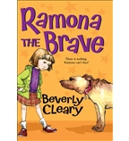](https://shop.scholastic.com/shop/en/teacherstore/product/Ramona-the-Brave)[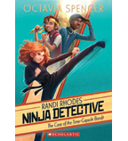](https://shop.scholastic.com/shop/en/teacherstore/product/The-Case-of-the-Time-Capsule-Bandit)[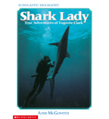](https://shop.scholastic.com/shop/en/teacherstore/product/Shark-Lady)[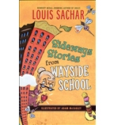](https://shop.scholastic.com/shop/en/teacherstore/product/Sideways-Stories-from-Wayside-School)[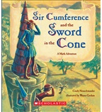](https://shop.scholastic.com/shop/en/teacherstore/product/Sir-Cumference-and-the-Sword-in-the-Cone) [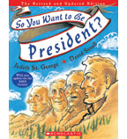](https://shop.scholastic.com/shop/en/teacherstore/product/So-You-Want-to-Be-President)[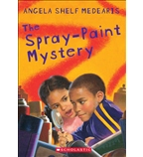](https://shop.scholastic.com/shop/en/teacherstore/product/The-Spray-Paint-Mystery)[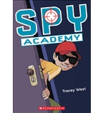](https://shop.scholastic.com/shop/en/teacherstore/product/Spy-Academy)[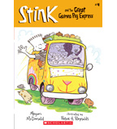](https://shop.scholastic.com/shop/en/teacherstore/product/Stink-and-the-Great-Guinea-Pig-Express)[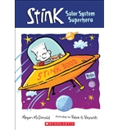](https://shop.scholastic.com/shop/en/teacherstore/product/Solar-System-Superhero)[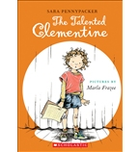](https://shop.scholastic.com/shop/en/teacherstore/product/The-Talented-Clementine)[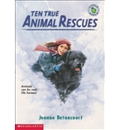](https://shop.scholastic.com/shop/en/teacherstore/product/Ten-True-Animal-Rescues)