[](https://shop.scholastic.com/shop/en/teacherstore/product/Long-Shot)[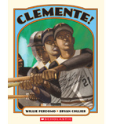](https://shop.scholastic.com/shop/en/teacherstore/product/Clemente)[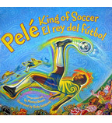](https://shop.scholastic.com/shop/en/teacherstore/product/Peleacute-King-of-Soccer--Peleacute-El-rey-de-fuacutetbol) [](https://shop.scholastic.com/shop/en/teacherstore/product/Playing-to-Win)

[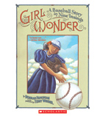](https://shop.scholastic.com/shop/en/teacherstore/product/Girl-Wonder)[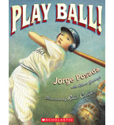](https://shop.scholastic.com/shop/en/teacherstore/product/Play-Ball)[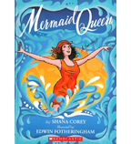](https://shop.scholastic.com/shop/en/teacherstore/product/Mermaid-Queen)[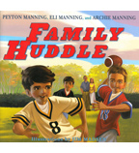](https://shop.scholastic.com/shop/en/teacherstore/product/Family-Huddle-9780545556071)

[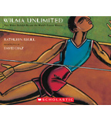](https://shop.scholastic.com/shop/en/teacherstore/product/Wilma-Unlimited)