[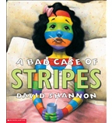](https://shop.scholastic.com/shop/en/teacherstore/product/A-Bad-Case-of-Stripes)[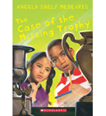](https://shop.scholastic.com/shop/en/teacherstore/product/The-Case-of-the-Missing-Trophy)[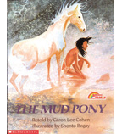](https://shop.scholastic.com/shop/en/teacherstore/product/The-Mud-Pony)[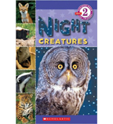](https://shop.scholastic.com/shop/en/teacherstore/product/Night-Creatures)