[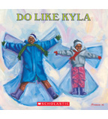](https://shop.scholastic.com/shop/en/teacherstore/product/Do-Like-Kyla) [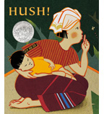](https://shop.scholastic.com/shop/en/teacherstore/product/Hush)[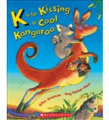](https://shop.scholastic.com/shop/en/teacherstore/product/K-Is-for-Kissing-a-Cool-Kangaroo)[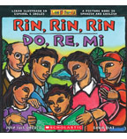](https://shop.scholastic.com/shop/en/teacherstore/product/Rin-Rin-Rin--Do-Re-Mi) [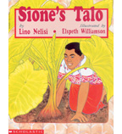](https://shop.scholastic.com/shop/en/teacherstore/product/Siones-Talo)