[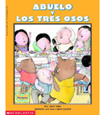](https://shop.scholastic.com/shop/en/teacherstore/product/Abuelo-and-the-Three-Bears--Abuelo-y-los-tres-osos)[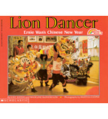](https://shop.scholastic.com/shop/en/teacherstore/product/Lion-Dancer) [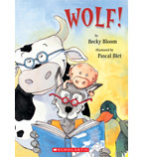](https://shop.scholastic.com/shop/en/teacherstore/product/Wolf)[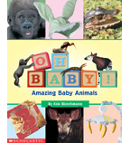](https://shop.scholastic.com/shop/en/teacherstore/product/Oh-Baby)