[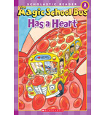](https://shop.scholastic.com/shop/en/teacherstore/product/The-Magic-School-Busreg-Has-a-Heart)