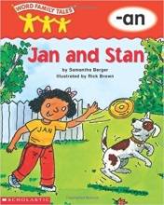 [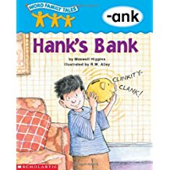](https://www.amazon.com/Word-Family-Tales-ank-Hanks/dp/0439262712/ref=sr_1_1?s=books&ie=UTF8&qid=1497023196&sr=1-1&keywords=9780439262712)[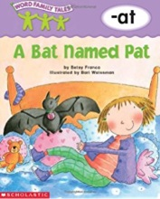](https://www.amazon.com/Word-Family-Tales-at-Named/dp/0439262666/ref=pd_sim_14_6?_encoding=UTF8&pd_rd_i=0439262666&pd_rd_r=Z7C3PJ8GYTWNFMKW7N84&pd_rd_w=9OFDA&pd_rd_wg=4CCQ4&psc=1&refRID=Z7C3PJ8GYTWNFMKW7N84) [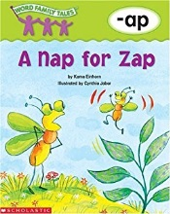](https://www.amazon.com/Word-Family-Tales-ap-Nap/dp/0439262690/ref=pd_sim_14_3?_encoding=UTF8&pd_rd_i=0439262690&pd_rd_r=858SJ77SH4VSXQY784AQ&pd_rd_w=nsEJl&pd_rd_wg=ZT5GR&psc=1&refRID=858SJ77SH4VSXQY784AQ)[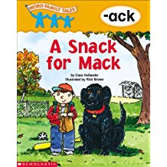](https://www.amazon.com/Word-Family-Tales-Snack-Mack-ebook/dp/B00H9GVGHO/ref=sr_1_27?s=books&ie=UTF8&qid=1497022766&sr=1-27&keywords=Word+Family+Tales)[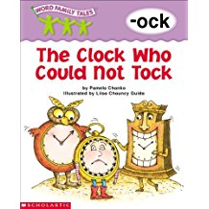](https://www.amazon.com/Word-Family-Tales-Clock-Could-ebook/dp/B00H9GVHKK/ref=sr_1_26?s=books&ie=UTF8&qid=1497022766&sr=1-26&keywords=Word+Family+Tales)[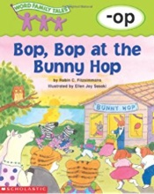](https://www.amazon.com/Word-Family-Tales-op-Bunny/dp/0439262615/ref=pd_sim_14_1?_encoding=UTF8&pd_rd_i=0439262615&pd_rd_r=858SJ77SH4VSXQY784AQ&pd_rd_w=nsEJl&pd_rd_wg=ZT5GR&psc=1&refRID=858SJ77SH4VSXQY784AQ) [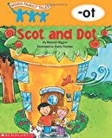](https://www.amazon.com/Word-Family-Tales-ot-Scot/dp/0439262631/ref=pd_sim_14_5?_encoding=UTF8&pd_rd_i=0439262631&pd_rd_r=Z7C3PJ8GYTWNFMKW7N84&pd_rd_w=9OFDA&pd_rd_wg=4CCQ4&psc=1&refRID=Z7C3PJ8GYTWNFMKW7N84) [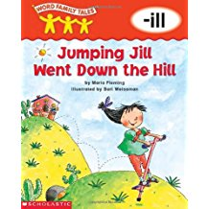](https://www.amazon.com/Word-Family-Tales-ill-Jumping/dp/0439262674/ref=sr_1_1?s=books&ie=UTF8&qid=1497023236&sr=1-1&keywords=9780439262675)[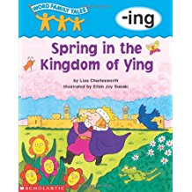](https://www.amazon.com/Word-Family-Tales-ing-Kingdom/dp/0439262607/ref=sr_1_24?s=books&ie=UTF8&qid=1497022727&sr=1-24&keywords=Word+Family+Tales)[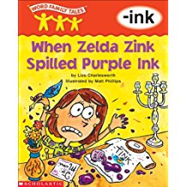](https://www.amazon.com/Word-Family-Tales-Zelda-Spilled-ebook/dp/B00H9GVHXC/ref=sr_1_19?s=books&ie=UTF8&qid=1497022727&sr=1-19&keywords=Word+Family+Tales)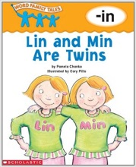 [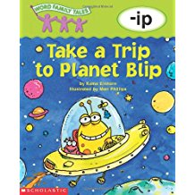](https://www.amazon.com/Word-Family-Tales-ip-Planet/dp/0439262518/ref=sr_1_1?s=books&ie=UTF8&qid=1497023321&sr=1-1&keywords=9780439262514) [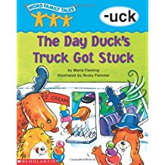](https://www.amazon.com/Word-Family-Tales-uck-Ducks/dp/043926264X/ref=sr_1_1?s=books&ie=UTF8&qid=1497023357&sr=1-1&keywords=9780439262644)[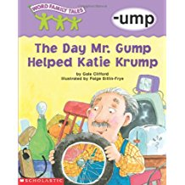](https://www.amazon.com/Word-Family-Tales-ump-Helped/dp/0439262534/ref=sr_1_17?s=books&ie=UTF8&qid=1497022661&sr=1-17&keywords=Word+Family+Tales) [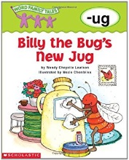](https://www.amazon.com/Word-Family-Tales-ug-Billy/dp/0439262526/ref=pd_sim_14_2?_encoding=UTF8&pd_rd_i=0439262526&pd_rd_r=858SJ77SH4VSXQY784AQ&pd_rd_w=nsEJl&pd_rd_wg=ZT5GR&psc=1&refRID=858SJ77SH4VSXQY784AQ) [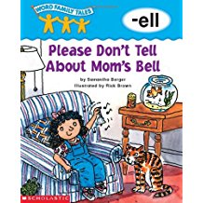](https://www.amazon.com/Word-Family-Tales-ell-Please/dp/0439262585/ref=sr_1_14?s=books&ie=UTF8&qid=1497022661&sr=1-14&keywords=Word+Family+Tales) [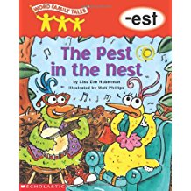](https://www.amazon.com/Word-Family-Tales-est-Pest/dp/0439262496/ref=sr_1_18?s=books&ie=UTF8&qid=1497022661&sr=1-18&keywords=Word+Family+Tales)[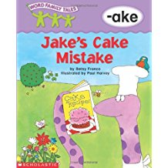](https://www.amazon.com/Word-Family-Tales-ake-Mistake/dp/0439262658/ref=sr_1_1?s=books&ie=UTF8&qid=1497023383&sr=1-1&keywords=9780439262651) [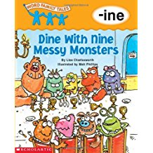](https://www.amazon.com/Word-Family-Tales-ine-Monsters/dp/043926250X/ref=sr_1_1?s=books&ie=UTF8&qid=1497023415&sr=1-1&keywords=9780439262507) [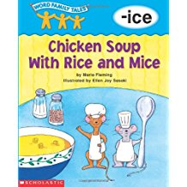](https://www.amazon.com/Word-Family-Tales-ice-Chicken/dp/0439262593/ref=sr_1_1?s=books&ie=UTF8&qid=1497023442&sr=1-1&keywords=9780439262590) [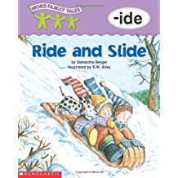](https://www.amazon.com/Word-Family-Tales-ide-Slide/dp/0439262720/ref=sr_1_5?s=books&ie=UTF8&qid=1497022604&sr=1-5&keywords=Word+Family+Tales)[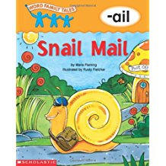](https://www.amazon.com/Word-Family-Tales-ail-Snail/dp/0439262623/ref=sr_1_16?s=books&ie=UTF8&qid=1497022661&sr=1-16&keywords=Word+Family+Tales)[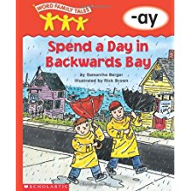](https://www.amazon.com/Word-Family-Tales-ay-Backwards/dp/0439262739/ref=sr_1_6?s=books&ie=UTF8&qid=1497022604&sr=1-6&keywords=Word+Family+Tales) [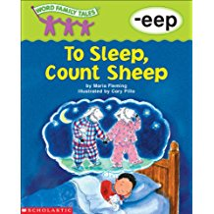](https://www.amazon.com/Word-Family-Tales-Sleep-Count-ebook/dp/B00H9GVHWI/ref=sr_1_4?s=books&ie=UTF8&qid=1497023519&sr=1-4&keywords=TO+SLEEP%2C+COUNT+SHEEP) [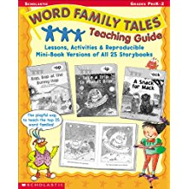](https://www.amazon.com/Word-Family-Tales-Teaching-Guide/dp/0439262488/ref=sr_1_7?s=books&ie=UTF8&qid=1497022604&sr=1-7&keywords=Word+Family+Tales)