[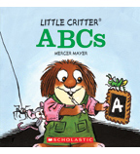](https://shop.scholastic.com/shop/en/teacherstore/product/ABCs) [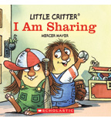](https://shop.scholastic.com/shop/en/teacherstore/product/I-Am-Sharing) [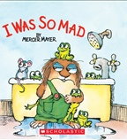](https://shop.scholastic.com/shop/en/teacherstore/product/I-Was-So-Mad) [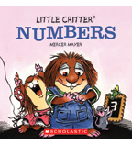](https://shop.scholastic.com/shop/en/teacherstore/product/Numbers-9780545849234)