[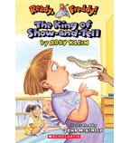](https://shop.scholastic.com/shop/en/teacherstore/product/King-of-Show-and-Tell)[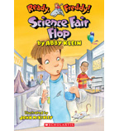](https://shop.scholastic.com/shop/en/teacherstore/product/Science-Fair-Flop)[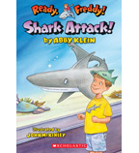](https://shop.scholastic.com/shop/en/teacherstore/product/Shark-Attack)[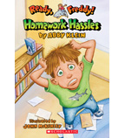](https://shop.scholastic.com/shop/en/teacherstore/product/Homework-Hassles)

[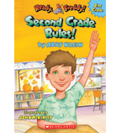](https://shop.scholastic.com/shop/en/teacherstore/product/Second-Grade-Rules)