[](https://shop.scholastic.com/shop/en/teacherstore/product/Lets-Go-to-the-Park) [](https://shop.scholastic.com/shop/en/teacherstore/product/Lets-Eat-9780545004138) [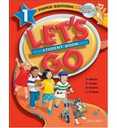](https://shop.scholastic.com/shop/en/teacherstore/product/Lets-Go-9780545004152)[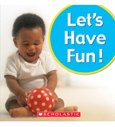](https://shop.scholastic.com/shop/en/teacherstore/product/Lets-Have-Fun)