[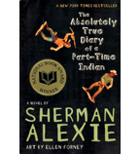](https://shop.scholastic.com/shop/en/teacherstore/product/The-Absolutely-True-Diary-of-a-Part-Time-Indian)[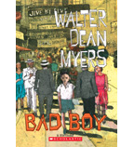](https://shop.scholastic.com/shop/en/teacherstore/product/Bad-Boy)[](https://shop.scholastic.com/shop/en/teacherstore/product/Behind-the-Eyes)[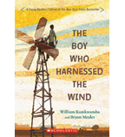](https://shop.scholastic.com/shop/en/teacherstore/product/The-Boy-Who-Harnessed-the-Wind-9780545946032)

[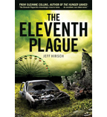](https://shop.scholastic.com/shop/en/teacherstore/product/The-Eleventh-Plague-9780545290159)[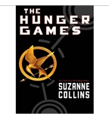](https://shop.scholastic.com/shop/en/teacherstore/product/The-Hunger-Games)[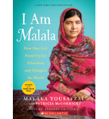](https://shop.scholastic.com/shop/en/teacherstore/product/I-Am-Malala-Young-Readers-Edition)[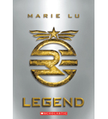](https://shop.scholastic.com/shop/en/teacherstore/product/Legend)

[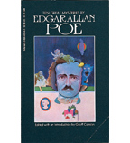](https://shop.scholastic.com/shop/en/teacherstore/product/Ten-Great-Mysteries-by-Edgar-Allan-Poe)