[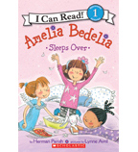](https://shop.scholastic.com/shop/en/teacherstore/product/Amelia-Bedelia-Sleeps-Over)[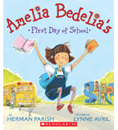](https://shop.scholastic.com/shop/en/teacherstore/product/Amelia-Bedelias-First-Day-of-School)[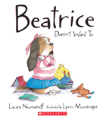](https://shop.scholastic.com/shop/en/teacherstore/product/Beatrice-Doesnt-Want-To)[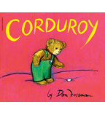](https://shop.scholastic.com/shop/en/teacherstore/product/Corduroy)

[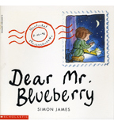](https://shop.scholastic.com/shop/en/teacherstore/product/Dear-Mr-Blueberry)[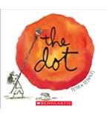](https://shop.scholastic.com/shop/en/teacherstore/product/The-Dot)[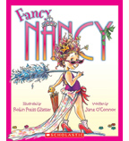](https://shop.scholastic.com/shop/en/teacherstore/product/Fancy-Nancy-9780545818902)[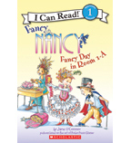](https://shop.scholastic.com/shop/en/teacherstore/product/Fancy-Day-in-Room-1-A)[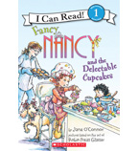](https://shop.scholastic.com/shop/en/teacherstore/product/Fancy-Nancy-and-the-Delectable-Cupcakes)

[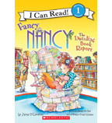](https://shop.scholastic.com/shop/en/teacherstore/product/The-Dazzling-Book-Report)[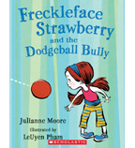](https://shop.scholastic.com/shop/en/teacherstore/product/Freckleface-Strawberry-and-Dodgeball-Bully)[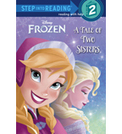](https://shop.scholastic.com/shop/en/teacherstore/product/Disney-Frozen-A-Tale-of-Two-Sisters-Step-into-Reading-Level-2)[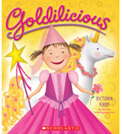](https://shop.scholastic.com/shop/en/teacherstore/product/Goldilicious)

[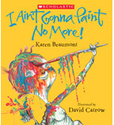](https://shop.scholastic.com/shop/en/teacherstore/product/I-Aint-Gonna-Paint-No-More)[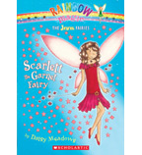](https://shop.scholastic.com/shop/en/teacherstore/product/Scarlett-the-Garnet-Fairy)[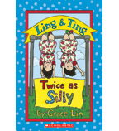](https://shop.scholastic.com/shop/en/teacherstore/product/Ling-amp-Ting-Twice-as-Silly)[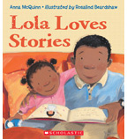](https://shop.scholastic.com/shop/en/teacherstore/product/Lola-Loves-Stories)[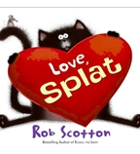](https://shop.scholastic.com/shop/en/teacherstore/product/Love-Splat)

[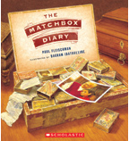](https://shop.scholastic.com/shop/en/teacherstore/product/The-Matchbox-Diary)[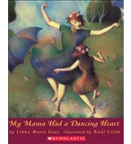](https://shop.scholastic.com/shop/en/teacherstore/product/My-Mama-Had-a-Dancing-Heart)