[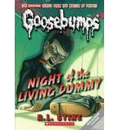](https://shop.scholastic.com/shop/en/teacherstore/product/Night-of-the-Living-Dummy)[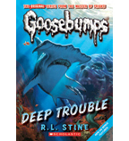](https://shop.scholastic.com/shop/en/teacherstore/product/Deep-Trouble)[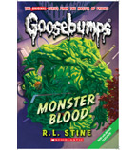](https://shop.scholastic.com/shop/en/teacherstore/product/Monster-Blood)[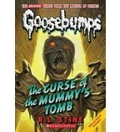](https://shop.scholastic.com/shop/en/teacherstore/product/Classic-Goosebumps-6-The-Curse-Of-The-Mummys-Tomb)

[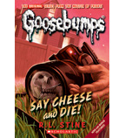](https://shop.scholastic.com/shop/en/teacherstore/product/Say-Cheese-and-Die)[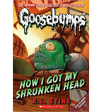](https://shop.scholastic.com/shop/en/teacherstore/product/Classic-Goosebumps-10-How-I-Got-My-Shrunken-Head)