[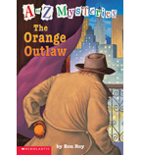](https://shop.scholastic.com/shop/en/tso/product/The-Orange-Outlaw)[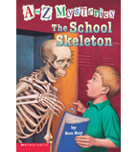](https://shop.scholastic.com/shop/en/tso/product/The-School-Skeleton)[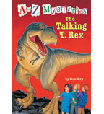](https://shop.scholastic.com/shop/en/tso/product/The-Talking-T-Rex)[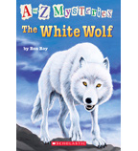](https://shop.scholastic.com/shop/en/tso/product/The-White-Wolf)

[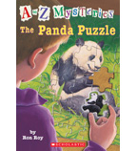](https://shop.scholastic.com/shop/en/tso/product/The-Panda-Puzzle)[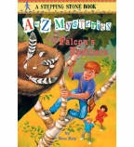](https://shop.scholastic.com/shop/en/tso/product/The-Falcons-Feathers)[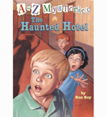](https://shop.scholastic.com/shop/en/tso/product/The-Haunted-Hotel)[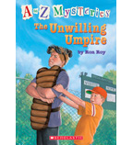](https://shop.scholastic.com/shop/en/tso/product/The-Unwilling-Umpire)

[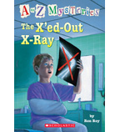](https://shop.scholastic.com/shop/en/tso/product/The-Xed-Out-X-Ray)[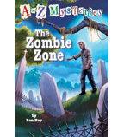](https://shop.scholastic.com/shop/en/tso/product/The-Zombie-Zone)