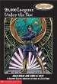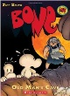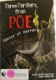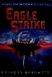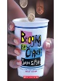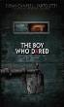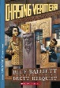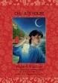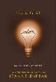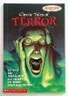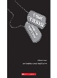]Drums, Girls and Dangerous PieImage result for 97804393552549780590458986: The Glory Field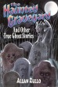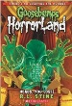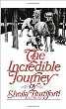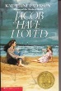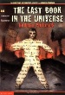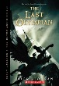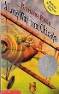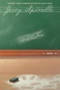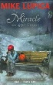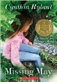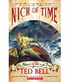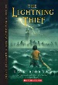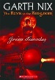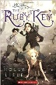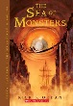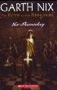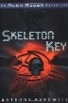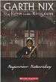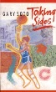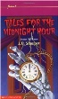Image result for 9780439095020Image result for 9780545057042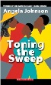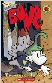Image result for 9781442426788