[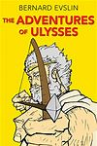](http://www.barnesandnoble.com/w/adventures-of-ulysses-bernard-evslin/1101884368?ean=9780606030793) [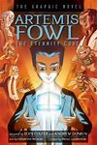](http://www.goodreads.com/book/show/13307719-the-supernaturalist) [](https://www.amazon.com/Attack-Pearl-Harbor-America-Entered/dp/0786816627) [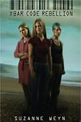](http://www.barnesandnoble.com/w/bar-code-rebellion-suzanne-weyn/1101013382?ean=9780545470551) [](http://www.barnesandnoble.com/w/the-best-ghost-stories-ever-christopher-krovatin/1006293100?ean=9780439574266) [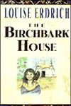](http://en.wikipedia.org/wiki/The_Birchbark_House) [](http://en.wikipedia.org/wiki/Black_Beauty) [](https://pictures.abebooks.com/isbn/9780439702249-us.jpg) 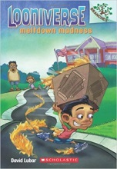 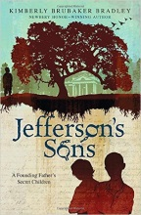 [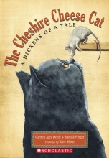](https://d3ddkgxe55ca6c.cloudfront.net/assets/a/9b/b6/148622-ml-998307.jpg) 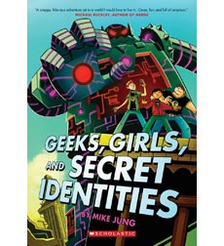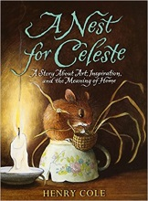 [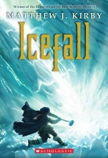](http://covers3.booksamillion.com/covers/bam/0/54/527/425/0545274257.jpg) 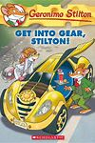  [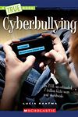](http://www.arbookfind.com/bookdetailprint.aspx?q=156888&l=EN&2k=) [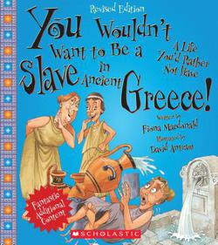](http://covers3.booksamillion.com/covers/bam/0/53/123/853/0531238539.jpg) [](http://www.barnesandnoble.com/w/civil-war-aaron-rosenberg/1100178261?ean=9780545237567) [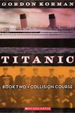](http://www.goodreads.com/book/show/9641078-collision-course) [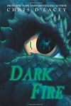](http://en.wikipedia.org/wiki/Dark_Fire_(The_Last_Dragon_Chronicles)) [](http://en.wikipedia.org/wiki/Color_Me_Dark) 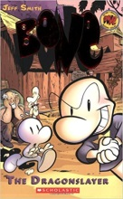 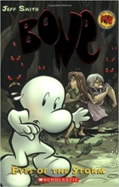 [](http://www.goodreads.com/book/show/3592.The_Fall_of_the_Amazing_Zalindas)   [](http://en.wikipedia.org/wiki/Fire_Star_(novel)) 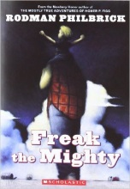 [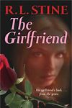](http://www.goodreads.com/book/show/89796.The_Girlfriend) 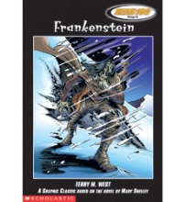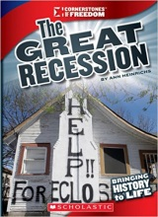 [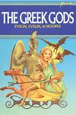](http://www.arbookfind.com/bookdetailprint.aspx?q=142996&l=EN&2k=) [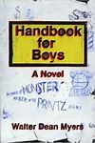](http://www.goodreads.com/book/show/579973.Handbook_for_Boys)   [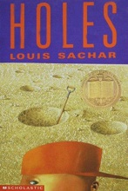](https://pictures.abebooks.com/isbn/9780439244190-us.jpg) 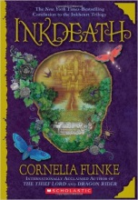 [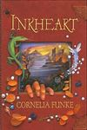](http://en.wikipedia.org/wiki/Inkheart) 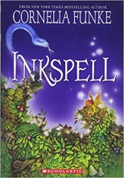 [](http://www.goodreads.com/book/show/454862.It_Only_Looks_Easy)  [](http://en.wikipedia.org/wiki/Kensuke's_Kingdom) 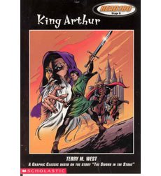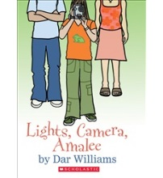 [](http://en.wikipedia.org/wiki/Millicent_Min,_Girl_Genius) 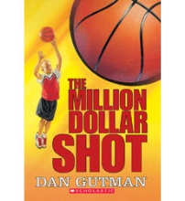[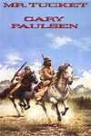](http://en.wikipedia.org/wiki/Mr._Tucket) [](http://www.goodreads.com/book/show/207888.The_Naked_Mole_Rat_Letters) [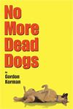](http://en.wikipedia.org/wiki/No_More_Dead_Dogs) [](http://en.wikipedia.org/wiki/The_Old_Willis_Place) 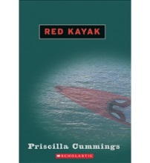[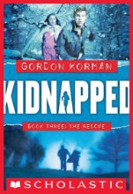](http://www.barnesandnoble.com/w/rescue-gordon-korman/1100836655;ean=9780439847797)  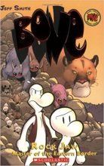 [](https://d3ddkgxe55ca6c.cloudfront.net/assets/a/79/95/144086-ml-873387.jpg) 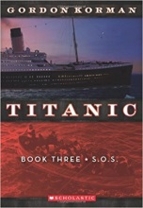 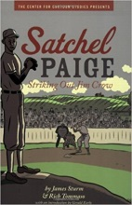 [](http://www.goodreads.com/book/show/6909206-the-secret-agent-and-other-spy-kids)  [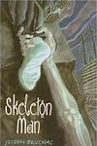](http://www.goodreads.com/book/show/670080.Skeleton_Man) [](http://www.barnesandnoble.com/w/slam-walter-dean-myers/1111717913?ean=9780590486682) 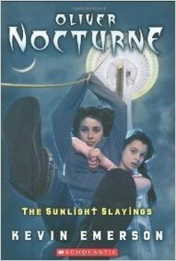 [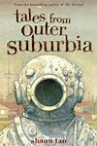](http://www.goodreads.com/book/show/2999495-tales-from-outer-suburbia) 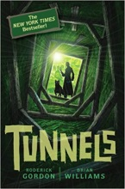 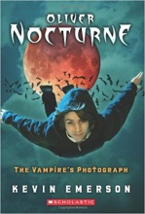 [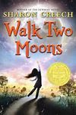](http://en.wikipedia.org/wiki/Walk_Two_Moons) 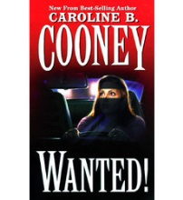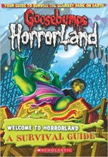 [](http://en.wikipedia.org/wiki/When_Hitler_Stole_Pink_Rabbit) [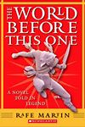](http://www.barnesandnoble.com/w/books/1005348397?ean=9780590379762) 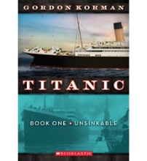[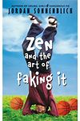](http://www.goodreads.com/book/show/728654.Zen_and_the_Art_of_Faking_It)[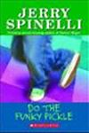](http://www.goodreads.com/book/show/87225.Do_The_Funky_Pickle) 