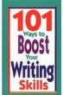 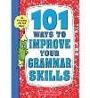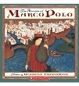 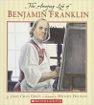 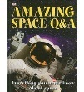 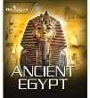 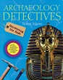 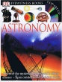 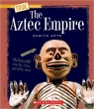 [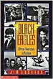](http://www.barnesandnoble.com/w/black-eagles-james-haskins/1112273373?ean=9780590459136) 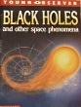 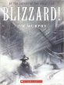 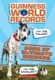 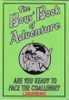 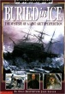 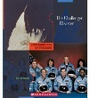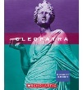 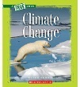  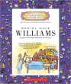 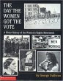 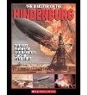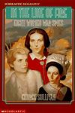 [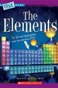](https://www.amazon.com/Elements-True-Books-Physical-Paperback/dp/0531265854) [](http://www.barnesandnoble.com/w/first-ladies-beatrice-gormley/1112536002) [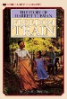](http://www.barnesandnoble.com/w/freedom-train-dorothy-sterling/1110858459?ean=9780590436281) 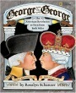 [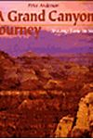](http://www.barnesandnoble.com/w/grand-canyon-journey-peter-anderson/1111850244?ean=9780531202593) 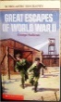 [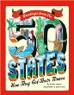](http://www.barnesandnoble.com/w/greetings-from-the-50-states-sheila-keenan/1110863822?ean=9780439834391) [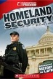](https://www.amazon.com/Homeland-Security-Cornerstones-Freedom-Third/dp/0531265617) 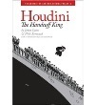[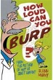](https://www.amazon.com/How-Loud-Can-You-Burp/dp/1596435062) 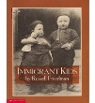 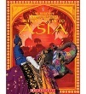  [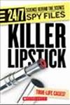](http://www.arbookfind.com/bookdetailprint.aspx?q=118386&l=EN&2k=) 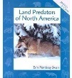 [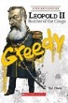](http://www.arbookfind.com/bookdetailprint.aspx?q=121283&l=EN&2k=) 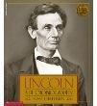 [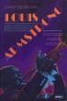](https://pictures.abebooks.com/isbn/9780531156803-uk.jpg) [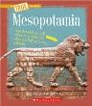](http://www.barnesandnoble.com/w/mesopotamia-sunita-apte/1103413520?ean=9780531241110) 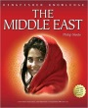 https://images-na.ssl-images-amazon.com/images/I/41dFb2cGlRL._SX279_BO1,204,203,200_.jpg [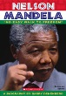](http://www.barnesandnoble.com/w/nelson-mandela-barry-denenberg/1111831470?ean=9780590441544) 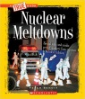 [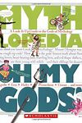](http://www.goodreads.com/book/show/6995908-oh-my-gods) 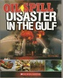 [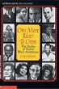](https://www.amazon.com/One-More-River-Cross-Americans/dp/0590428977) 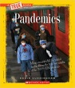  [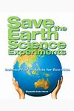](http://www.barnesandnoble.com/w/save-the-earth-science-experiments-elizabeth-snoke-harris/1112224011?ean=9781600593222) 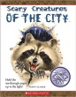 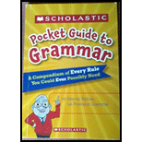 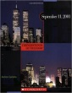 [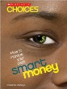](http://www.barnesandnoble.com/w/smart-money-danielle-denega/1111833565?ean=9780531147726) 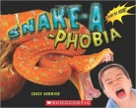 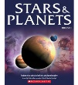 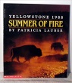 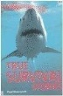  [](https://www.amazon.com/DK-Biography-Thomas-Jan-Adkins/dp/0756652065) 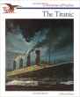 [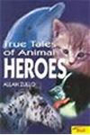](http://www.goodreads.com/book/show/2230166.True_Tales_of_Animal_Heroes) 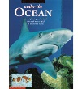 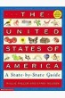   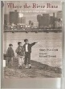  [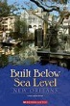](http://www.arbookfind.com/bookdetailprint.aspx?q=118171&l=EN&2k=) 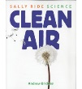 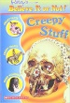 [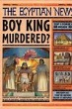](http://www.barnesandnoble.com/w/egyptian-news-scott-steedman/1102493076?ean=9780763604233) 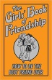 [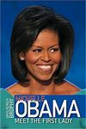](http://www.goodreads.com/book/show/4955599-michelle-obama) [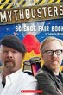](http://www.barnesandnoble.com/w/mythbusters-science-fair-book-samantha-margles/1101097864?ean=9780545237451) [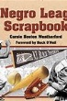](http://www.goodreads.com/book/show/286902.A_Negro_League_Scrapbook) [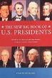](http://www.barnesandnoble.com/w/the-new-big-book-of-u-s-presidents-marc-frey/1103235506?ean=9780762408498) 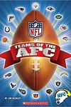 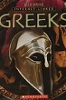 [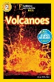](http://www.barnesandnoble.com/w/volcanoes-anne-schreiber/1103224883) [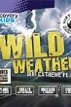](https://www.amazon.com/Wild-Weather-Discovery-Parragon-Books/dp/1472307682) [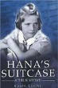](http://www.barnesandnoble.com/w/hanas-suitcase-karen-levine/1100995684?ean=9780807531471) [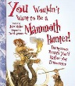](http://covers4.booksamillion.com/covers/bam/0/53/116/397/0531163970.jpg) 