[](http://www.barnesandnoble.com/w/american-indian-festivals-jay-miller/1002114006) [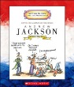](http://www.barnesandnoble.com/w/andrew-jackson-mike-venezia/1007244577?ean=9780516274812) 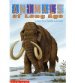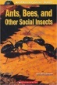 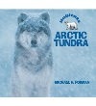 [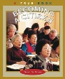](http://covers3.booksamillion.com/covers/bam/0/51/627/366/0516273663.jpg) 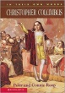 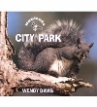 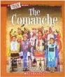 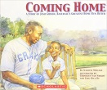 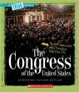 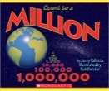  [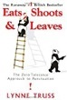](https://www.amazon.com/Eats-Shoots-Leaves-Tolerance-Punctuation/dp/1592402038/ref=pd_lpo_sbs_14_img_0?_encoding=UTF8&psc=1&refRID=RGNBABZQSYT0YH0DTSWT) 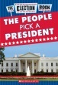 [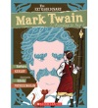](https://shop.scholastic.com/teachers-ecommerce/books/the-extraordinary-mark-twain-according-to-susy-9780545341271.html)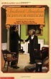 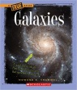 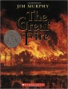 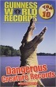 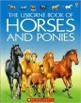 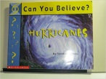 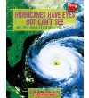 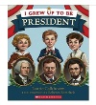[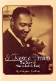](http://covers2.booksamillion.com/covers/bam/0/59/044/230/0590442309.jpg) 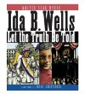 [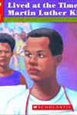](http://www.goodreads.com/book/show/196427.If_You_Lived_at_the_Time_of_Martin_Luther_King) 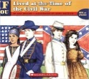 [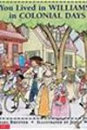](http://www.arbookfind.com/bookdetailprint.aspx?q=52594&l=EN&2k=) 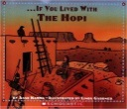 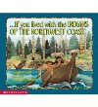 [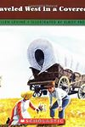](http://www.goodreads.com/book/show/401814.If_You_Traveled_West_In_A_Covered_Wagon) 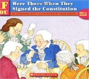 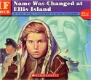 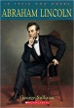 [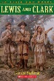](http://www.barnesandnoble.com/w/lewis-and-clark-george-sullivan/1004505841) 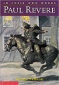 [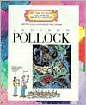](http://www.barnesandnoble.com/w/jackson-pollock-mike-venezia/1103623160?ean=9780516422985) [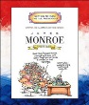](http://www.barnesandnoble.com/w/james-monroe-mike-venezia/1102953511) 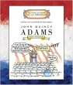 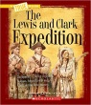 [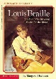](http://covers1.booksamillion.com/covers/bam/0/59/044/350/059044350X.jpg) [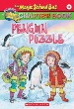](http://www.barnesandnoble.com/w/penguin-puzzle-judith-bauer-stamper/1103462030?ean=9780439204224) 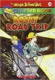 [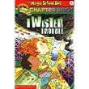](https://www.amazon.com/Twister-Trouble-Magic-School-Chapter/dp/0439204194/ref=sr_1_1?s=books&ie=UTF8&qid=1495807418&sr=1-1&keywords=9780439204194)[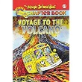](https://www.amazon.com/Magic-School-Science-Chapter-Book/dp/0439429358/ref=sr_1_1?s=books&ie=UTF8&qid=1495807443&sr=1-1&keywords=9780439429351) [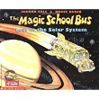](https://www.amazon.com/Magic-School-Lost-Solar-System/dp/0590414291/ref=sr_1_1?s=books&ie=UTF8&qid=1495807468&sr=1-1&keywords=9780590414296) [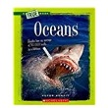](https://www.amazon.com/Oceans-True-Books-Ecosystems-Paperback/dp/0531281051/ref=sr_1_1?s=books&ie=UTF8&qid=1495807491&sr=1-1&keywords=9780531281055) 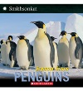 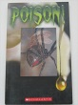 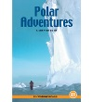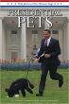 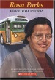 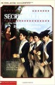 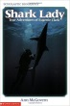 [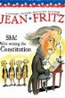](http://www.goodreads.com/book/show/823068.Shh_We_re_Writing_the_Constitution) 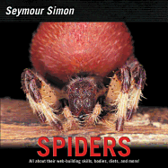 [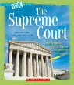](http://www.barnesandnoble.com/w/supreme-court-christine-taylor-butler/1102172894) [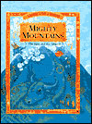](http://www.barnesandnoble.com/w/swampland-brian-e-ableman/1002458725?ean=9780516203744) [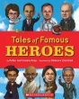](https://d3ddkgxe55ca6c.cloudfront.net/assets/a/25/55/145132-ml-904397.jpg) 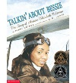 [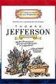](https://www.amazon.com/Thomas-Jefferson-President-1801-1809-Presidents/dp/0516274775) 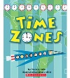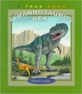 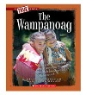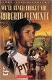 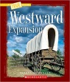 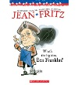[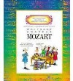](http://covers3.booksamillion.com/covers/bam/0/51/644/541/0516445413.jpg) 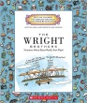 [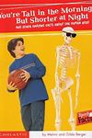](https://www.amazon.com/Youre-Tall-Morning-Short-Night/dp/0439549787) 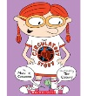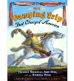[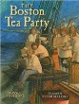](https://covers.openlibrary.org/b/id/7432532-L.jpg) 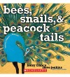 [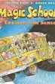](http://www.goodreads.com/book/show/110956.The_Magic_School_Bus_Explores_the_Senses) 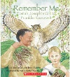 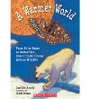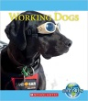 [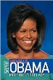](http://www.barnesandnoble.com/w/michelle-obama-david-bergen-brophy/1015660409?ean=9780061779909) 